Class activity CO3
Name: M.Nandhini
Reg.No: 192472318
- Multiple catch statements
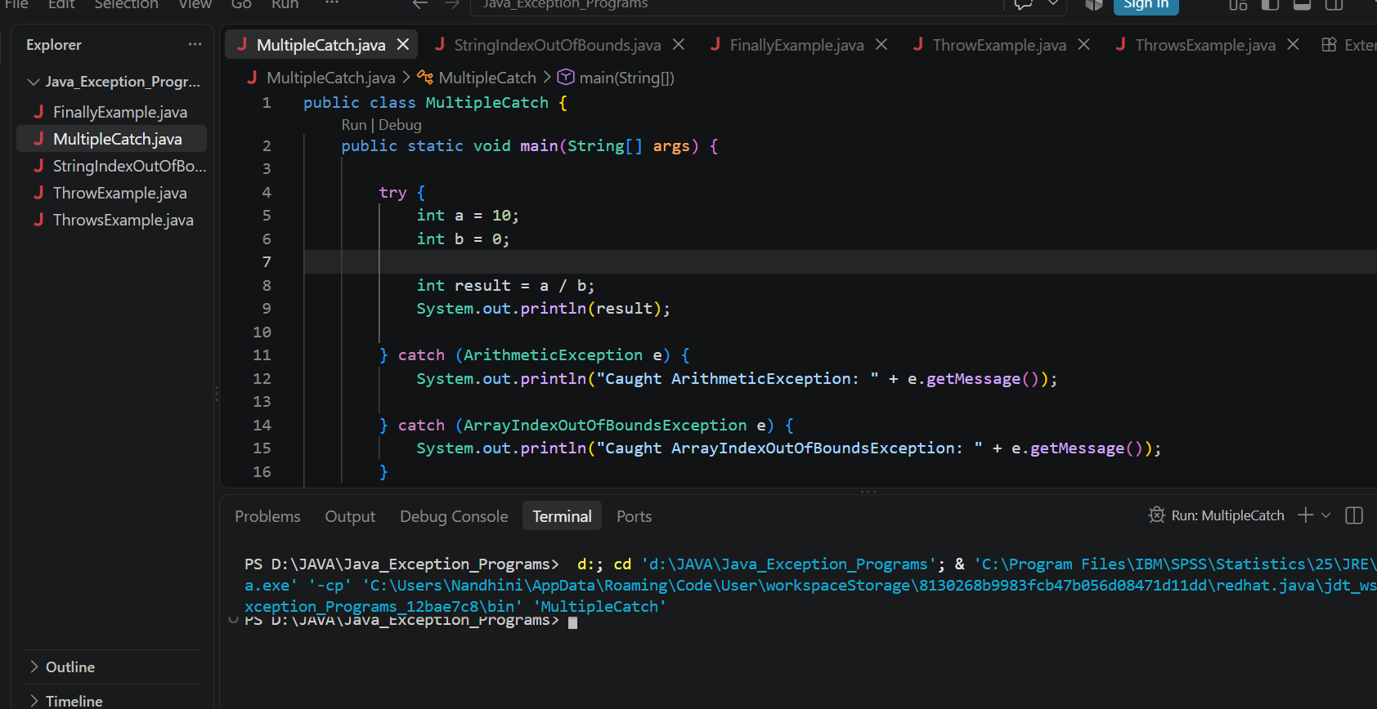
2. StringIndexOfBoundsException
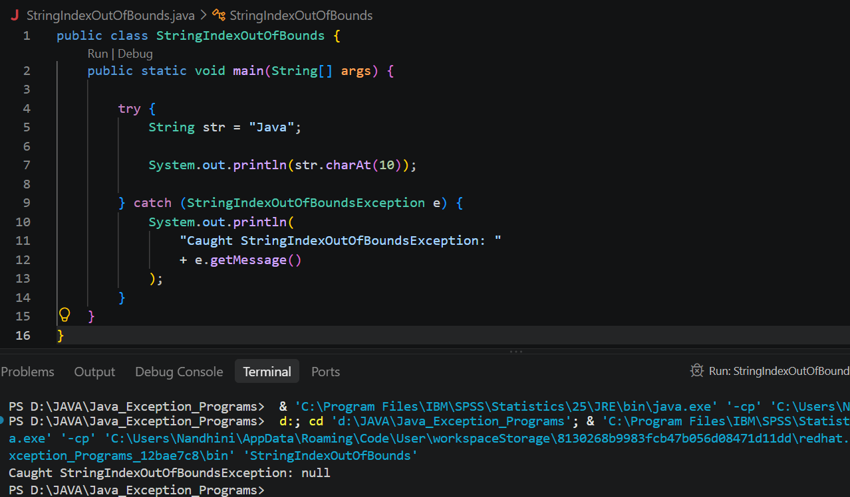
3. Finally
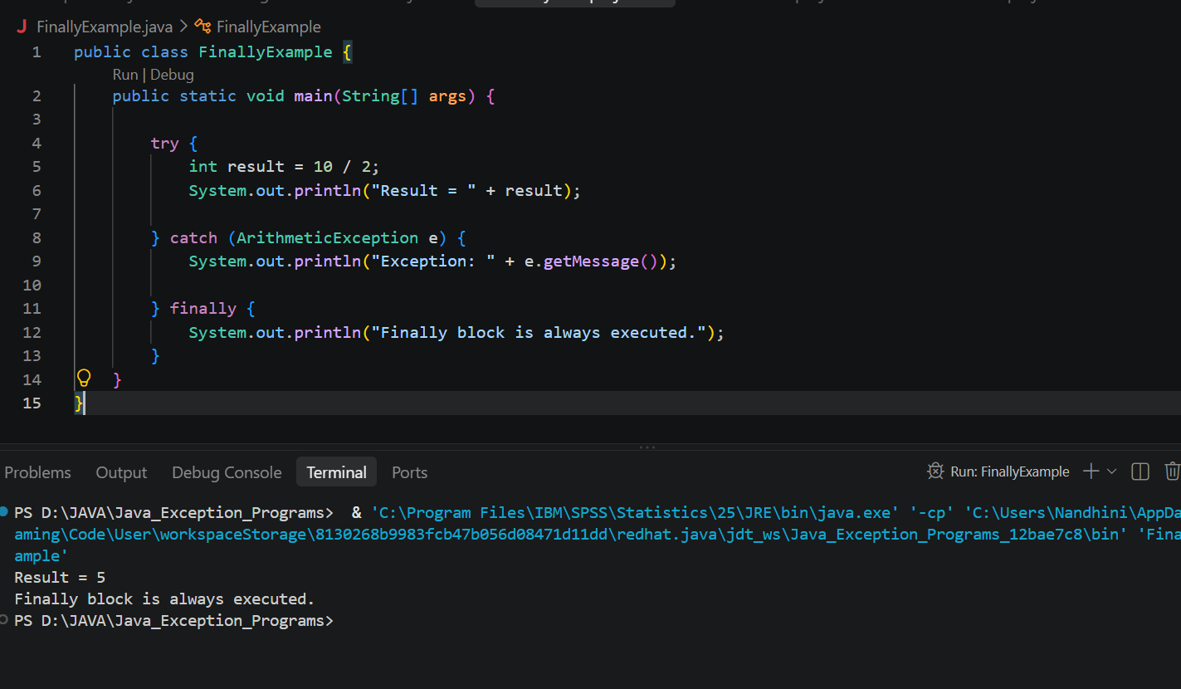
4. throw (to check person is eligible to poll the vote)
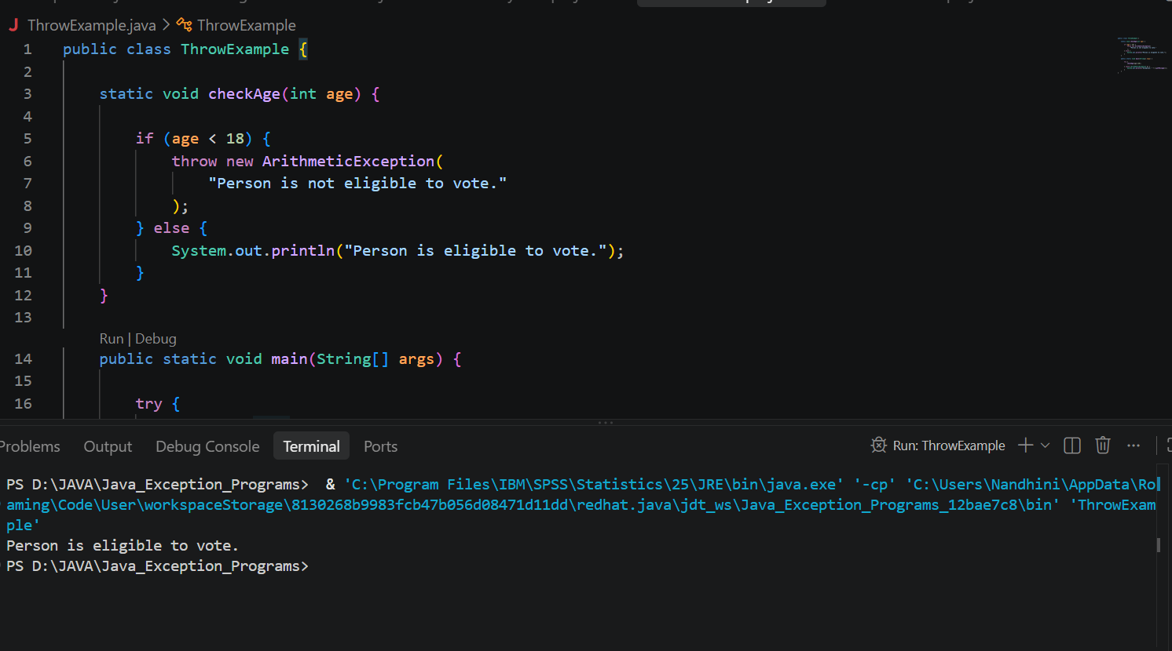
5. Throws
